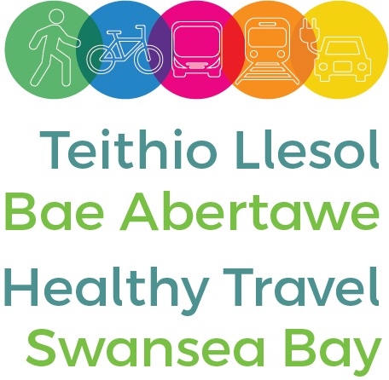

Media release
25 May 2022
Swansea University hosted the launch of the Swansea Bay Healthy Travel Charter today, signed by 11 leading organisations from across the region.
At the Bay Campus, the University, along with Swansea Bay University Health Board, Natural Resources Wales, the Driver and Vehicle Licensing Agency (DVLA), Gower College, National Waterfront Museum, Swansea Council, Swansea Council for Voluntary Service, Neath Port Talbot Council for Voluntary Service, Coastal Housing and Pobl, agreed to help staff and visitors travel to their sites in a sustainable way.
Through 17 ambitious actions, the charter promotes walking, cycling, public transport and ultra-low emission vehicle use.
The actions include establishing a network of sustainable travel champions within each organisation, developing targeted communications campaigns for staff, offering and promoting the cycle to work scheme and promoting public transport discounts.
By working together, the organisations aim to increase the proportion of journeys made to and from workplaces which are sustainable.
The public sector in Swansea employs over a third of working adults, over 42,000 people, so this commitment can have a significant positive impact on the environment as well as associated health benefits.
The launch of this charter comes as the evidence of the urgency needed to tackle climate change becomes stark. The UN secretary general referred to the Intergovernmental Panel on Climate Change (IPCC)'s report in August 2021 as 'code red for humanity', and the co-chair of the IPCC's working group said in February 2022 that "the scientific evidence is unequivocal: climate change is a threat to human wellbeing and the health of the planet. Any further delay in concerted global action will miss a brief and rapidly closing window to secure a liveable future." The Swansea Bay Healthy Travel Charter is the fifth Charter to launch in Wales, following similar initiatives in Cardiff, the Vale of Glamorgan and Gwent, and with businesses.
Professor Paul Boyle, Vice-Chancellor of Swansea University said: “We are delighted to host the launch of the Swansea Bay Healthy Travel Charter at our Bay Campus today.
“To support our ambition to be a zero carbon University by 2035, we are committed to working together with our local and regional partners to deliver the bold actions outlined in the charter. This will build upon the excellent work already initiated by our University staff and students, to encourage our community to consider more active and sustainable transport options, such as walking, cycling and using public transport.”
Mark Hackett, Chief Executive of Swansea Bay University Health Board said: "Swansea Bay University Health Board is delighted to be one of the first signatories to the Swansea Bay Healthy Travel Charter. We know that getting people walking, cycling and taking public transport can significantly benefit the health of our residents, not only reducing the risk of cardiovascular disease and diabetes, but improving mental wellbeing too, and improving air quality for everyone. As part of NHS Wales we are also committed to rapidly reducing our carbon emissions to do our bit to address the climate emergency. We look forward to working with our partners to implement the commitments in the Charter."
More information on the Charter is available at healthytravel.wales/swanseabay and teithiollesol.cymru/baeabertawe
ENDS

Assets

